**T - Test**

The Independent Samples *t* Test compares the means of two independent groups in order to determine whether there is statistical evidence that the associated population means are significantly different. The Independent Samples *t* Test is a parametric test.

Data required

1. dependent variable
2. independent variable

var1 independent has four values

1. man

2. women

3. others

4. I don't want to answer

dependent variable

It refers to the number of minutes, which are spent by women and men on social media for learning

purpose.

Hypothesis

1. H0 = null hypothesis

(μ1=μ2).

There is no difference between women students and men students in the time spent on social

media for learning purpose.

2. H1= alternative hypothesis

(μ1≠μ2)

There is a difference between women students and men students in the time spent on social

media for learning purpose.

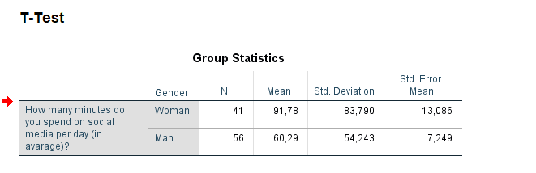

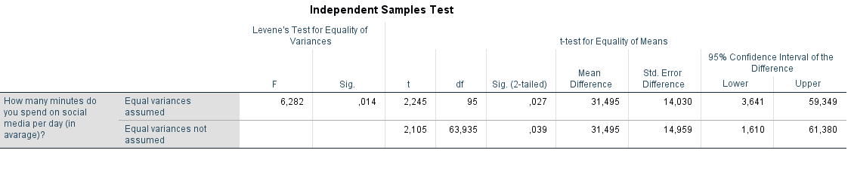

We can see that significant value is .014 which is less than .05 so its means null hypothesis is not valid There is a difference between women students and men students in the time spent on social media for learning purpose.

**ANOVA TEST**

Anova test compares the means of two or more independent groups in order to determine whether there is statistical evidence that the associated population means are significantly different. One-Way ANOVA is a parametric test.

1 Dependent variable

2 Independent variable

The null and alternative hypotheses of one-way ANOVA can be expressed as:

*H*0: µ1 = µ2 = µ3 = ... = µk ("all *k* population means are equal")

*H*1: At least one µi different ("at least one of the *k* population means is not equal to the others")where µi is the population mean of the ith group (*i* = 1, 2, ..., *k*)

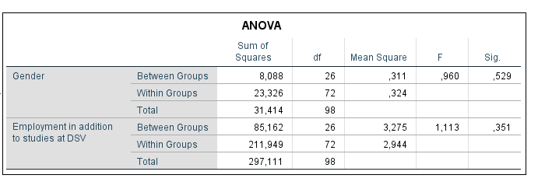

Hence H0 is correct because there is no difference between gender and employed number of minutes which spent on social media for purpose learning.

**Correlation TEST**

Correlation produces a sample correlation coefficient, *r*, which measures the strength and direction of linear relationships between pairs of continuous variables

*H*0: *ρ* = 0 ("the population correlation coefficient is 0; there is no association")

*H*1: ρ ≠ 0 ("the population correlation coefficient is not 0; a nonzero correlation could exist")

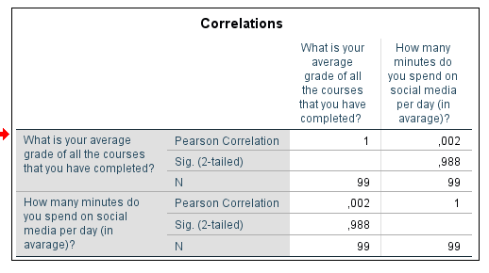

The significant value is .988, which is greater than .05, which means null hypothesis is valid.